Taking necessary actions if dataset varies

Empathy Map

**IOT BASED SMART CROP PROTECTION SYSTEM FOR**

**AGRICULTURE**

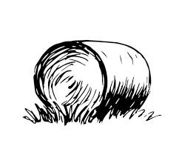

Based on

Time managing

Farmer financial loss

Prevent fire accidents

Increased

crop production

W

Well monitoring the crops

Seed feeding by birds

Well balanced environment

Animals/ Birds repulsion system

Provides protection to field as well as no harm to animals

Air temperature & Soil moisture monitor

Increased income

Sending alert to farmers

Protecting crops for day and night

Failure in crop harvest

Loss in yield

Crop destruction by animal